Giving Trends & Next Steps
With the Coronavirus (COVID-19) spreading across the US, tanking the stock market and sowing fear, nonprofit leaders are naturally wondering what the impact will be on giving. It’s a fair and important question. Let me try and give some perspective.
- Giving tends to be recession-resistant. It’s important to know that historically, giving in current dollars has maintained or even increased in recessionary years (see the Giving USA chart below). The one exception is the “Great Recession” from 2007-2009. So when the economy struggles, it’s not unreasonable to see that charitable organizations can weather that storm with donors who are committed to the organizations they care about most.
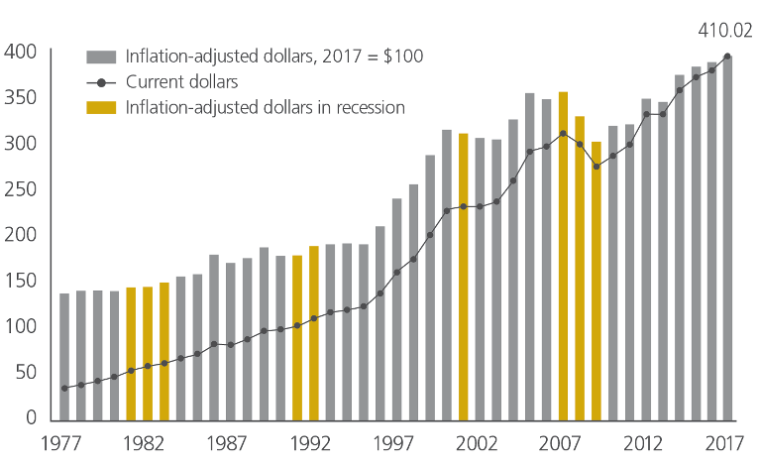
- What we are currently experiencing is a mitigation impact, not a causative impact. Here’s what I mean. The fast-moving changes we are experiencing currently are the result of measures being employed that are seeking to mitigate the impact of the virus and not because the virus has spread ubiquitously. For example, the 30-day restriction of flights from Europe is a dramatic step to try and keep the virus from spreading into America. So is the suspension of NBA games and the fact the March Madness will go on without any spectators. The implication? If the mitigation steps are effective, the impact should be short-lived, including the impact on the stock market.
- Timing is everything. If the stock market was tanking in December (think the end of 2018), we would see a direct and severe impact on year-end giving and overall giving for the year. Because the virus has hit so early in the year, it allows a period for recovery before the most important time of the year for giving… if the mitigation efforts prove successful.
So what should you do? A couple of pieces of advice.
- It’s vital for you to address with your donors the reality your organization is facing as a result of the Coronavirus. Be honest. Especially if it has a direct impact on the services you deliver and/or you’re seeing a direct impact on your income.
- Keep your donors focused on the importance of your mission and the lives that are being impacted because of the donor’s ongoing support. More than ever you need to be proactive to stay in front of your donors in a meaningful and sensitive way and to keep them engaged with your cause.
- Be relevant by making sure your communication doesn’t seem disconnected from the reality impacting so many lives. This is tricky but you can’t seem to your donors and constituents that you’re unaware of all that is impacting their lives. You have to continue to ensure their support for your cause continues.
There’s no doubt that this is an exceptional challenge. But it can be navigated successfully if you are thoughtful, strategic, and proactive.
Best regards,
Rick Dunham
Founder+CEO

